 VINOD SIR’S GROUP TUTION

MARKS: 12 IX-MATHS-I TIME: 1 Hr. 30 Mins.

Q. 1: 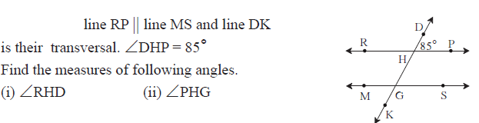 [2]
Q. 2: 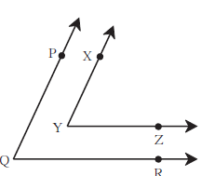 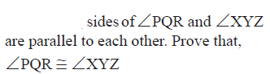[3]
Q. 3: 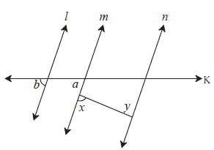 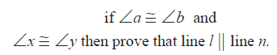 [2]
Q. 4: 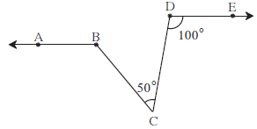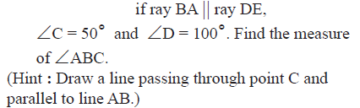[2]
Q. 5: 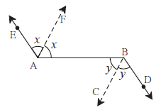 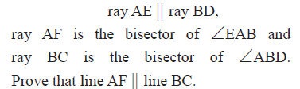[3]

